Fundamentals of Data Science - Lab Manual

7. Scenario: You are working as a data analyst for an e-commerce company. You have been given a dataset containing information about customer orders, stored in a Pandas Data Frame named order_data. The Data Frame has columns for customer ID, order date, product name, and order quantity. Your task is to analyze the data and answer specific questions about the orders. Question: Using Pandas Data Frame operations, how would you find the following information
from the order_data DataFrame:
1. The total number of orders made by each customer.
2. The average order quantity for each product.
3. The earliest and latest order dates in the dataset.
import pandas as pd
order_data = pd.DataFrame({
'customer_id': [101, 102, 101, 103, 102],
'order_date': ['2026-10-01', '2026-10-02', '2026-10-03', '2026-10-04', '2026-10-05'],
'product_name': ['Pen', 'Book', 'Pen', 'Pencil', 'Book'],
'order_quantity': [2, 4, 3, 5, 6]})
print("Orders by customer:")
print(order_data.groupby('customer_id').size())
print("Average quantity by product:")
print(order_data.groupby('product_name')['order_quantity'].mean())
print("Earliest order date:")
print(order_data['order_date'].min())
print("Latest order date:")
print(order_data['order_date'].max())
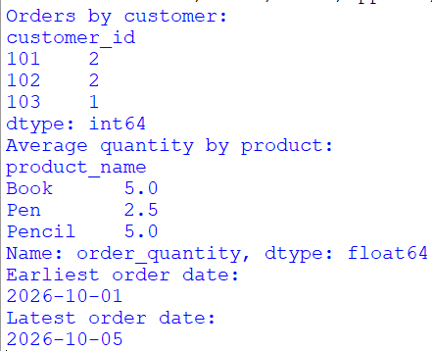

8. Scenario: You are a data scientist working for a company that sells products online. You have been tasked with analyzing the sales data for the past month. The data is stored in a Pandas dataframe.Question: How would you find the top 5 products that have been sold the most in the past month?

import pandas as pd
df = pd.DataFrame({ 'product_name': ['Pen', 'Book', 'Pen', 'Pencil',
'Book', 'Bag', 'Scale'],
'quantity': [20, 15, 30, 10, 25, 40, 12],
'order_date': ['2026-10-01', '2026-10-03', '2026-10-05',
'2026-10-06', '2026-10-07', '2026-10-08', '2026-10-09']})
df['order_date'] = pd.to_datetime(df['order_date'])
last_month = df[ df['order_date'] >= pd.Timestamp('2026-10-01')]
top5 = last_month.groupby('product_name')['quantity'].sum()
top5 = top5.sort_values(ascending=False).head(5)
print("Top 5 Best-Selling Products:")
print(top5)

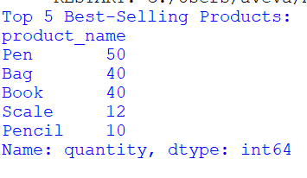
9. Scenario: You work for a real estate agency and have been given a dataset containing
information about properties for sale. The dataset is stored in a Pandas DataFrame named property_data. The DataFrame has columns for property ID, location, number of bedrooms, areain square feet, and listing price. Your task is to analyze the data and answer specific questions about the properties. Question: Using Pandas DataFrame operations, how would you find the following information from the property_data DataFrame:
1. The average listing price of properties in each location.
2. The number of properties with more than four bedrooms.
3. The property with the largest area.

import pandas as pd

property_data = pd.DataFrame({
'property_id': [1, 2, 3, 4, 5],
'location': ['Chennai', 'Madurai', 'Chennai',
'Salem', 'Madurai'],
'bedrooms': [3, 5, 4, 6, 2],
'area_sqft': [1200, 2000, 1500, 2500, 1000],
'listing_price': [5000000, 7000000, 6000000,
8000000, 4000000]
})

print("Average Listing Price by Location:")
print(property_data.groupby('location')['listing_price'].mean())

print("Properties with More Than 4 Bedrooms:")
print((property_data['bedrooms'] > 4).sum())

print("Property with Largest Area:")
print(property_data.loc[property_data['area_sqft'].idxmax()])
